How to convert your website visitors into paying customers

Made by: Hristo Hristov

Class: S3 - CB04

Contents

1. First impressions are the most important 3

2. Make it easy for customers to find what they want 3

3. Make it easy for them to give you their money 4

4. Building a connection with the customer 4

5. Give the customer the care they need 4

# First impressions are the most important

When a customer visits your website, you have a most 3 seconds to impress them before they click away. Having a good-looking homepage with the most interesting articles on display will increase the number of conversions significantly.

# Make it easy for customers to find what they want

Even if customers stay after the 3 seconds of looking at your website if they cannot find the items that they are looking for they will leave. Make sure that search for items is easy by having a lot of filters that the customers can use to narrow down the number of items displayed to only those that would interest them

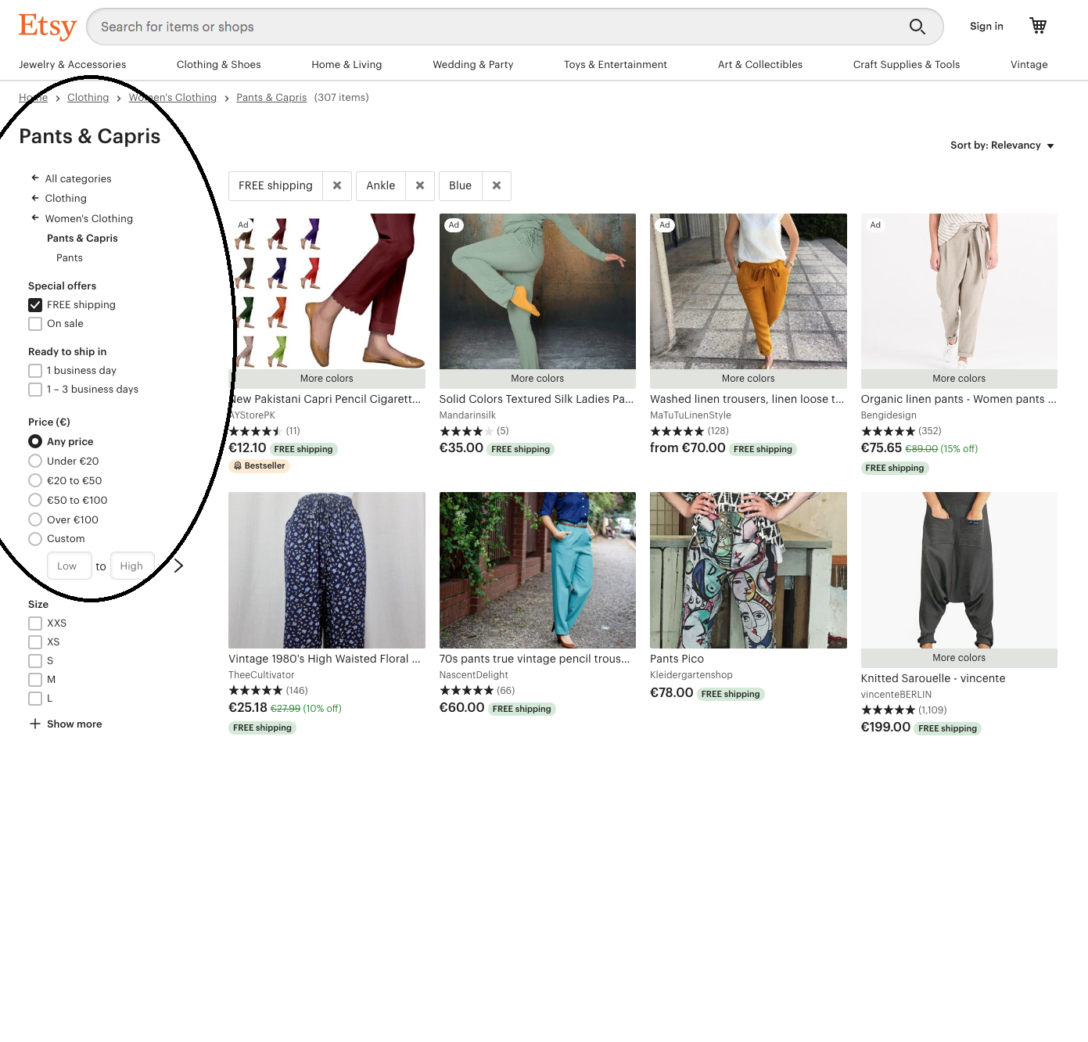

# Make it easy for them to give you their money

Buying the items that a person has selected should be the best part of their experience with your web shop. The entire process should consist of the customer adding the item they want to their cart and checking out.

# Building a connection with the customer

While having an account should not be necessary when using your website, being able to have one will make the customers experience more personalized. Having a history of all purchased orders from the customer that they can see will build trust between the customer and your website and will encourage them to purchase again.

# Give the customer the care they need

Another thing that will help you in the conversion is an outstanding customer care. A Forrester research states that 45% of US consumers will abandon an online transaction if their questions or concerns are not addressed quickly. One way to fix this problem is by making your chat with an employee option not only available for when there is a problem but to answer any questions on the product page that the customer may have.

